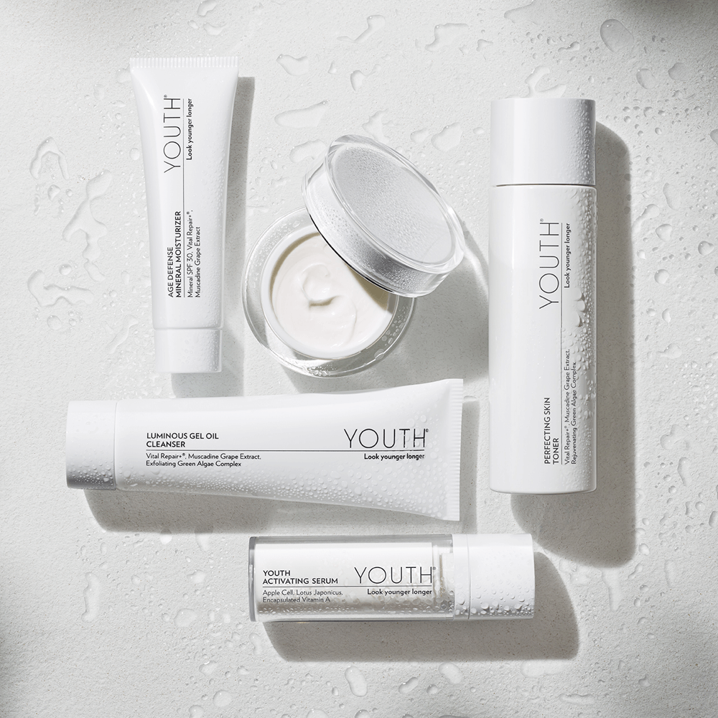
SPECIAL GIFT through December 31: Get a FREE Radiance C+E ($94 value) when you purchase the new Advanced Anti-Aging Regimen and place on Autoship.†
PLUS through September 30 ONLY: Receive an exclusive silver YOUTH cosmetic bag with each purchase of the new Advanced Anti-Aging Regimen.†
The entire Advanced Anti-Aging Regimen was designed to work together for improved skin texture, radiance, and firmness, and reducing the appearance of wrinkles. Formulated with active anti-aging ingredients in every single product in the line, YOUTH provides treatment benefits in each of the four simple steps.
100% of women had younger-looking skin and 2/3 shifted their skin age into a younger decade. Get started today. The Advanced Anti-Aging Regimen includes:
- Step 1: Luminous Gel Oil Cleanser – 3-in-1, soap-free, pH-balanced cleanser. Gently polish, purify and prepare your skin.
- Step 2: Perfecting Skin Toner – Free your skin of dull cells and environmental pollutants. Exfoliate, hydrate and nourish for glowing skin.
- Step 3: Youth Activating Serum – 10X the actives to provide the critical regeneration step. Renews skin at the cellular level for superior radiance and rejuvenation.
- Step 4 Day: Age Defense Mineral Moisturizer – Naturally derived zinc oxide provides chemical-free SPF 30 Broad Spectrum UVA/UVB protection. Vitamins and botanicals moisturize your skin and improve skin tone.
- Step 4 Night: Advanced Renewal Night Cream – This targeted night repair cream supports your skin's cell renewal process. A proprietary botanical blend helps collagen and elastin production to make skin appear younger looking, smoother, and more luminous. Available in Light or Rich formulas.
YOUTH products are all 100% vegan, cruelty free and gluten free. Each YOUTH product shown contains a 60-day supply.
† Offer Rules
- Offer is available from through Sunday, December 31, 2017.
- The Free Radiance C+E offer is so amazing we’re only offering it one time per Member or Distributor ID.
- Suggested Retail Price: $294.10
- Item: #89453

Contact:

